FH-DCE Super Rally in the past
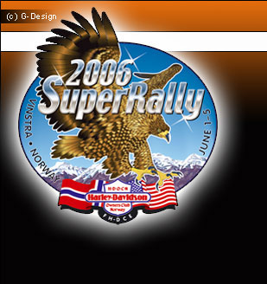  2006  Vinstra, Norway  Harley-Davidson Owners Club Norway | 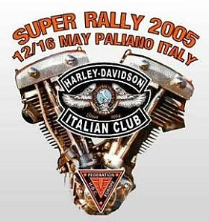  2005  Italy, Paliano  Harley-Davidson Italian Club
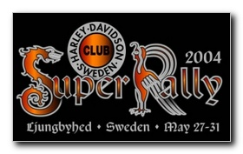  2004  Sweden, Ljungbyhed  H-DC Sweden | 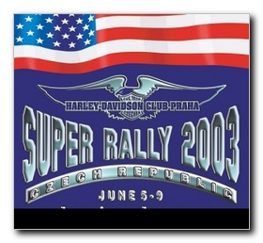  2003  CZ Republic, Ceske Budejovice  H-DC Praha
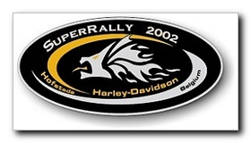  2002  Belgium, Hofstade  H-DC Flanders | 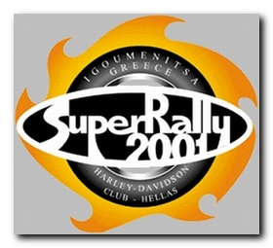  2001  Greece, Igoumenitsa  H-DC Hellas
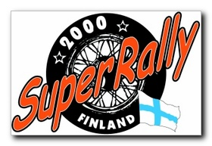  2000  Finland, Himos  H-DC Finland | 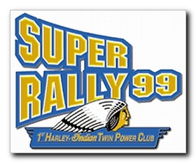  1999  Austria, Wiener Neustadt  1st Harley-Indian Twin Power Club
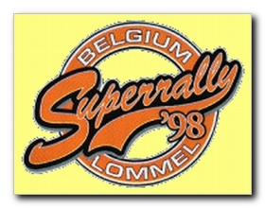  1998  Belgium, Lommel  H-D Riders Route 66 | 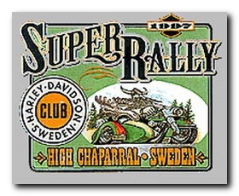  1997  Sweden, High Chaparral  H-DC Sweden
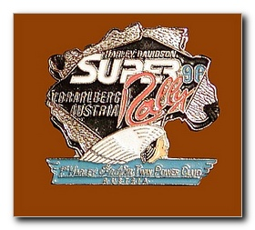  1996  Austria, Voralberg - Nenzing  1st Harley-Indian Twin Power Club | 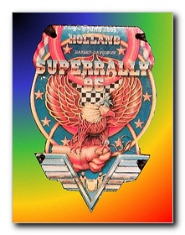  1995  Netherland, Valkenswaard  H-DC ´s Hertogenbosch
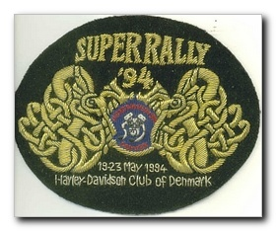  1994  Denmark, Silkeborg  H-DC Denmark | 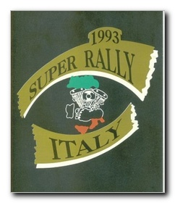  1993  Italy, Murazzano safari park  H-D Riders Italy
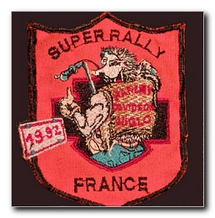  1992  France, Paris  H-DC Niglo | 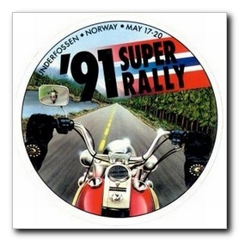  1991  Norway, Lillehammer  H-DOC Norway
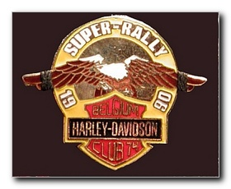  1990  Belgium, Charleroi  H-DC Belgium 7 | 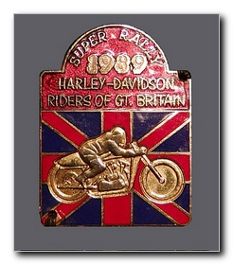  1989  Great Britain, Longmarston Raceway  H-D Riders Great Britain
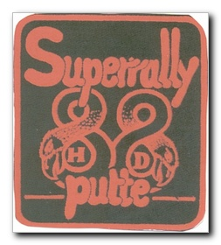  1988  Belgium, Accosse, Liege  H-DC Putte, Netherlands  The little mountain run | 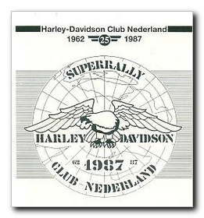  1987  Netherland, Slagharen  H-DC Netherlands
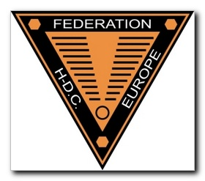  1986  Denmark, Stevingshus  H-DC Denmark | 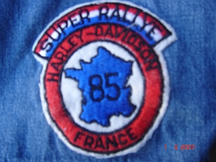  1985  France, Jablines-Paris
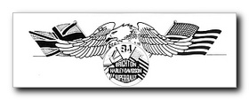  1984  Great Britain, Brighton  H-D Riders Great Britain | 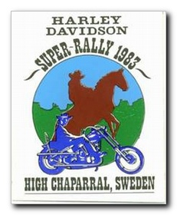  1983  Sweden, High Chaparral  H-DC Sweden
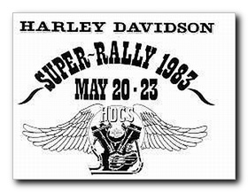  1983  Sweden, High Chaparral  H-DC Sweden | 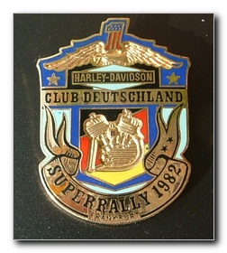  1982  Germany, Frankfurt  H-DC Deutschland
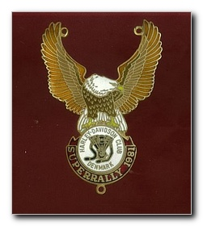  1981  Denmark, Ring Djursland  H-DC Denmark | 1980  France  H-DC France
1979  Great Britain, Brands Hatch  H-D Riders Great Britain | 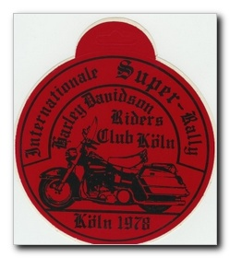  1978  Germany, Köln  This SR was organized by the  H-D Riders of Cologne,  the club which was the foundation-stone  of the Harley-Davidson Club Deutschland
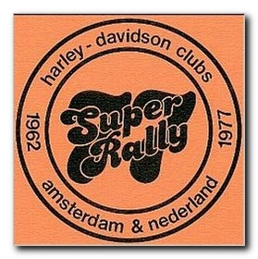  1977  Netherland, Limburg-Geulle  H-DC Netherlands  H-DC Amsterdam | 1976  Sweden, Simlĺngsdalen  H-DC Sweden
1975  Belgium, Kasterlee | 1974  France, Paris
1973  Great Britain,Hereford  H-D Riders Great Britain | 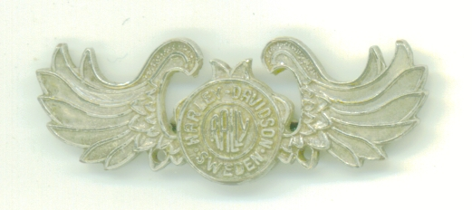  1972  Sweden  H-DC Sweden

